DATABASE PROJECT
TOPIC: EPOKA CLUBS SYSTEM

MEMBERS:
Viola Zeneli (Leader)
Sidrit Rrustemi
Noel Zani
Nikol Dalipi
Suada Terolli
Alesia Dardha

WORK DIVISON:
Viola Zeneli: ER Diagram, Relational Schema, Indexes and 25 Managerial Queries
Sidrit Rrustemi: Web Interface (FrontEnd)
Nikol Dalipi: SQL code (creation and instertion) for Advisor, Supervises and an UPDATE example
Noel Zani: SQL code (creation and instertion) for Students, participatesIn, isMemberOf and normalization example
Suada Terolli: SQL code (creation and instertion) for DOSEmployee, Reports and an UPDATE example
Alesia Dardha: SQL code (creation and instertion) for Club, Event and a DELETE example

- PROJECT OUTLINE AND PLANNING

The project to develop a database for the Epoka Clubs system stems from the growing need for universities to foster extracurricular activities through student clubs while ensuring efficient management of these activities. By addressing the growing need for data organization and accessibility the project aims to support both the university's administrative staff and the students participating in various clubs.

The first step of our project was collecting information about Epoka Clubs, so that we had a better understanding before we created our own database. We had a discussion with the Student Clubs and Activities Specialist and later we explored the already created website for Epoka Clubs on the internet.

After that we discussed as a group and shared our opinions which entities to create and how they are related. After we all agreed on our groups er diagram, then Viola made it in ERDPlus. Based on the ERD, she also made the Relational Schema on ERDPlus.

Then the work was divided in this way :
Nikol, Suada and Alesia took each 2 entities from our ERD. They created the relations, inserted values and provided update and delete examples.
Noel took 3 entities and created the relations and inserted values for them. She also provided an example for normalization (changing 1 of our tables just to give an example, since all our tables were already normalized).

After they finished, Viola checked all the codes and joined them all together. Meanwhile Sidrit continued his work on front end part, so that when the sql was all finished by the girls, he could only connect the sql with his front end.

After Viola joined all the sql codes, she continued to create indexes for each table column so that the speed was increased when we perform select operations, since her next task was to create 25 managerial queries.

After all sql was finished, then Sidrit connect it with his front end, and our epoka clubs database and website are ready now.

- RESEARCH AND IDEA CONSOLIDATION

Normalization:

Normalization avoids data duplication and inconsistencies, making the database faster, more reliable, and easier to maintain. Since all our tables were already normalized (on 3rd normal form), Noel provided an example how to normalize the table if it were not normalized.

Our tables satisfy 3NF because the design eliminates redundancy, ensures all non-prime attributes depend directly on the primary key, and removes any dependencies between non-prime attributes.

This ensures data integrity and prevents anomalies (e.g., insertion, update, and deletion anomalies), which are critical for maintaining a reliable and efficient database.

Indexing :

As for the speed, indexing was implemented for each column ,by Viola, to enhance query performance, especially for frequently searched attributes such as Student IDs, Club IDs, and Event dates.

Indexing is a critical feature in relational databases that improves the performance of query execution.

Even though indexes consume extra storage, they allow the database to locate and access data more quickly instead of scanning the entire table for each query.

- PROJECT EXECUTION

Entity-Relationship Diagram (ERD)
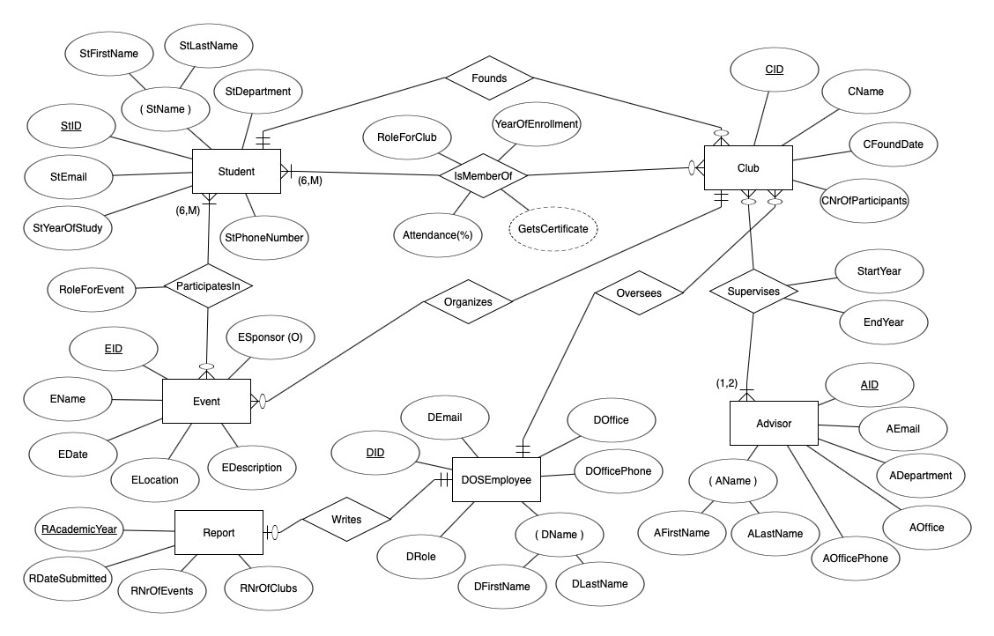

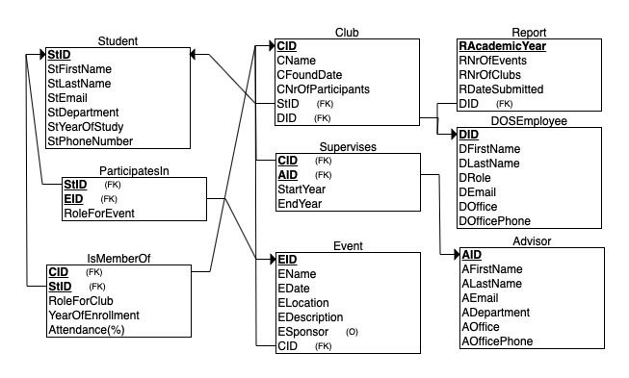
Relational Schema

SQL CODE (Create relations, insert values, create indexes, make queries)

- Advisor

CREATE TABLE Advisor(
AID CHAR PRIMARY KEY,
AFirstName VARCHAR(20) NOT NULL,
ALastName VARCHAR(20) NOT NULL,
AEmail VARCHAR(50) NOT NULL,
ADepartment VARCHAR(100) NOT NULL,
AOffice CHAR(4) NOT NULL,
AOfficePhone INT NOT NULL
);

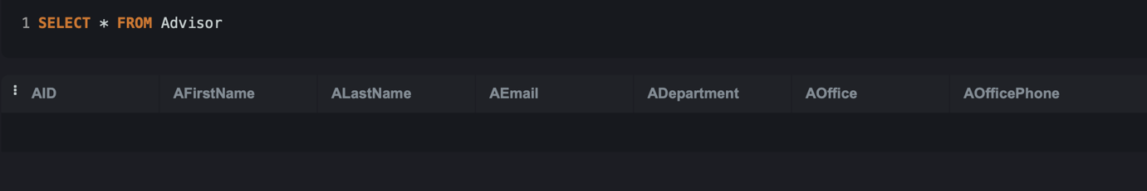

INSERT INTO Advisor (AID, AFirstName, ALastName, AEmail, ADepartment, AOffice, AOfficePhone) VALUES
('A', 'Sabrina', 'Begaj', 'sbegaj@epoka.edu.al', 'Computer Engineering', 'E007', 1533),
('B', 'Redjola', 'Manaj', 'manaj@epoka.edu.al', 'Computer Engineering', 'A106', 1551),
('C', 'Andia', 'Tafa', 'atafa@epoka.edu.al', 'Computer Engineering', 'A120', 1578),
('D', 'Valmir', 'Bame', 'vbame@epoka.edu.al', 'Computer Engineering', 'E202', 1670),
('E', 'Ari', 'Gjerazi', 'agjerazi@epoka.edu.al', 'Computer Engineering', 'E108', 1542);

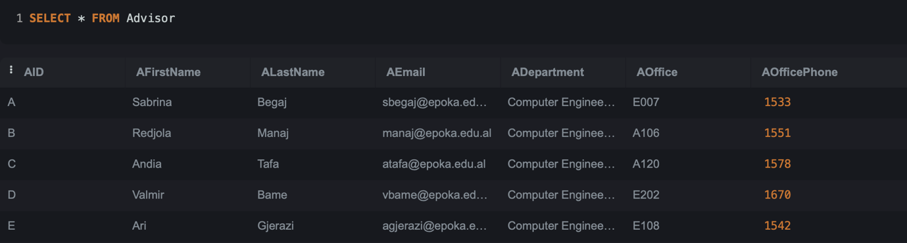

From this table, the dependency can be identified as:

AID -> AFirstName, ALastName, AEmail, ADepartment, AOffice, AOfficePhone (FKD)

- Supervises

CREATE TABLE Supervises(
AID CHAR NOT NULL,
CID INT NOT NULL,
StartYear INT NOT NULL,
EndYear INT,
PRIMARY KEY (AID, CID),
FOREIGN KEY (AID) REFERENCES Advisor (AID) ON DELETE CASCADE ON UPDATE RESTRICT,
FOREIGN KEY (CID) REFERENCES Club (CID) ON DELETE CASCADE ON UPDATE RESTRICT );

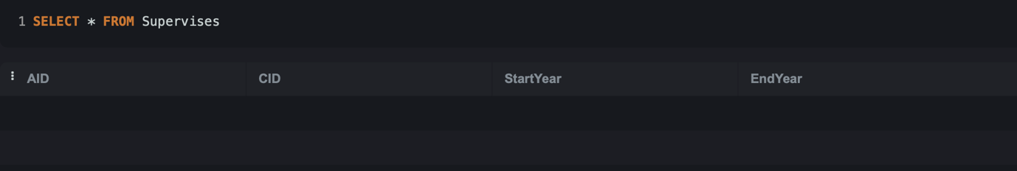

INSERT INTO Supervises (AID, CID, StartYear, EndYear) VALUES
('A', 5, 2021, NULL),
('C', 18, 2018, 2022),
('E', 9, 2023, NULL),
('B', 11, 2019, 2023),
('C', 7, 2024, NULL);

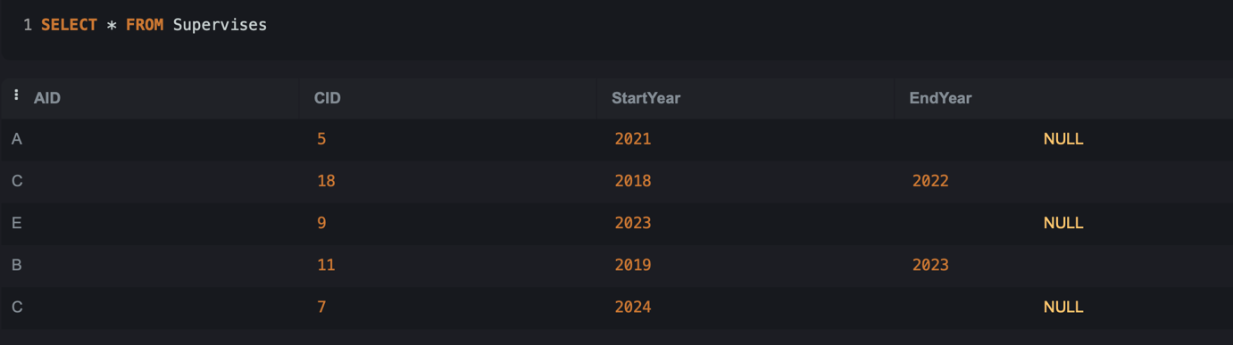

Advisor and Club hold a many-to-many relationship (though a club is usually supervised by 1 or 2 advisors).

From this table, the dependency can be identified as:

AID, CID -> StartYear, EndYear (FKD)

UPDATE EXAMPLE

Let’s suppose we want to update the Office Phone of one of the Advisors:

UPDATE Advisor
SET AOfficePhone = 1654
WHERE AOfficePhone = 1551;

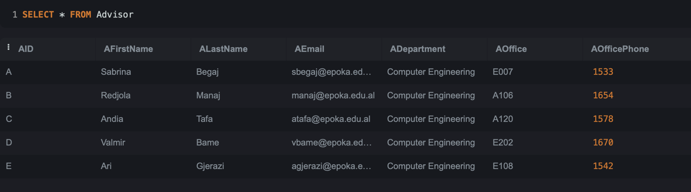

The Office Phone of Advisor Redjola Manaj has been updated.

- Students

CREATE TABLE Students
(StID CHAR(5) NOT NULL,
StFName VARCHAR (25) NOT NULL,
StLName VARCHAR (25) NOT NULL,
StDepartment VARCHAR (5) NOT NULL,
StEmail VARCHAR (20) NOT NULL,
StPhoneNumber VARCHAR(10) NOT NULL,
StYearOfStudy INT (1) NOT NULL,
PRIMARY KEY (StID) );
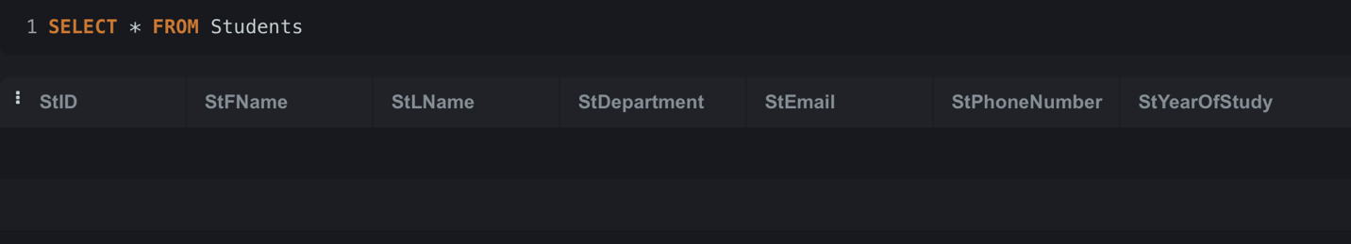

INSERT INTO Students(StID, StFName, StLName, StDepartment, StEmail, StPhoneNumber, StYearOfStudy) VALUES
('12345','Noel','Zani','SWE','nzani23@epoka.edu.al','0695436572','2'),
('11223','Viola','Zeneli','SWE','vzeneli23@epoka.edu.al','0693453496','2'),
('22453','Teddy','Daniels','BINF','tdaniels22@epoka.edu.al','0671253675','3'),
('25341','Nikol','Dalipi','SWE','ndalipi23@epoka.edu.al','0673916235','1'),
('12546','James','Conway','CEN','jconway24@epoka.edu.al','0691890744','1'),
('32546','Sidrit','Rrustemi','SWE','srrustemi23@epoka.edu.al','0695722508','2'),
('26743','Suada','Terolli','SWE','sterolli23@epoka.edu.al','0675647890','1'),
('19364','Joe','Pesci','IML','jpesci22@epoka.edu.al','0682501370','3'),
('37628','Alesia','Dardha','SWE','adardha23@epoka.edu.al','0691096341','2'),
('46378','Henry','Hill','CEN','hhill22@epoka.edu.al','0690749216','3');
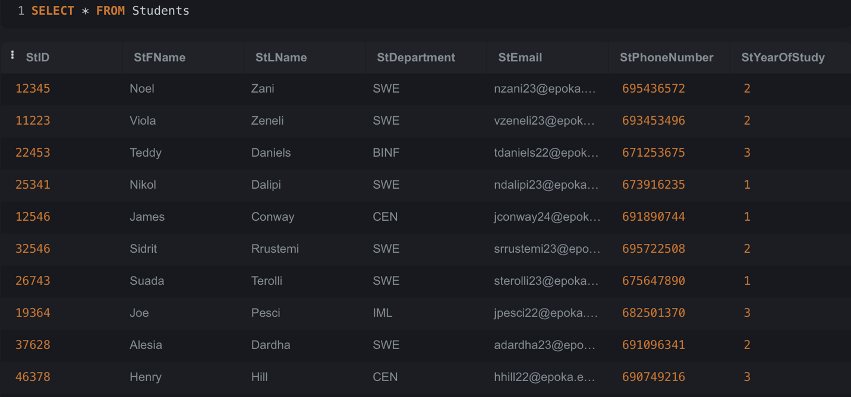

- isMemberOf

CREATE TABLE isMemberOf
(StID CHAR (5) NOT NULL,
CID INT NOT NULL,
RoleForClub VARCHAR (15) NOT NULL,
YearOfEnrollment INT (4) NOT NULL,
Attendance INT (3) NOT NULL,
PRIMARY KEY (StID, CID),
FOREIGN KEY (StId) REFERENCES Students (StId) ON DELETE CASCADE ON UPDATE RESTRICT,
FOREIGN KEY (CID) REFERENCES Club (CID) ON DELETE CASCADE ON UPDATE RESTRICT);
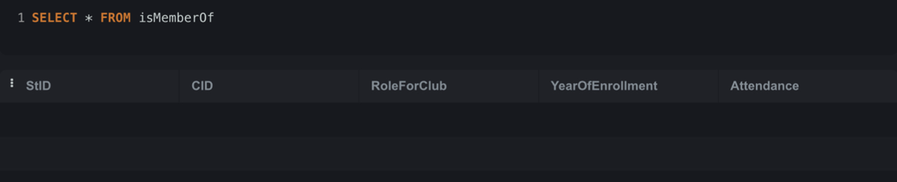

INSERT INTO isMemberOf(StID, CID, RoleForClub, YearOfEnrollment, Attendance) VALUES
('25341','2','President','2024','100'),
('12546','2','VicePresident','2024','96'),
('37628','2','Member','2023','87'),
('26743','2','Member','2024','50'),
('11223','2','Secretary','2024','98'),
('12345','2','Treasurer','2023','90'),
('32546','2','Member','2024','95'),
('22453','2','Member','2022','68'),
('46378','5','Member','2022','78'),
('12345','5','President','2023','100'),
('19364','5','Member','2022','67'),
('11223','5','Treasurer','2023','70'),
('22453','5','VicePresident','2022','94'),
('26743','5','Member','2024','88'),
('32546','5','Secretary','2023','90');

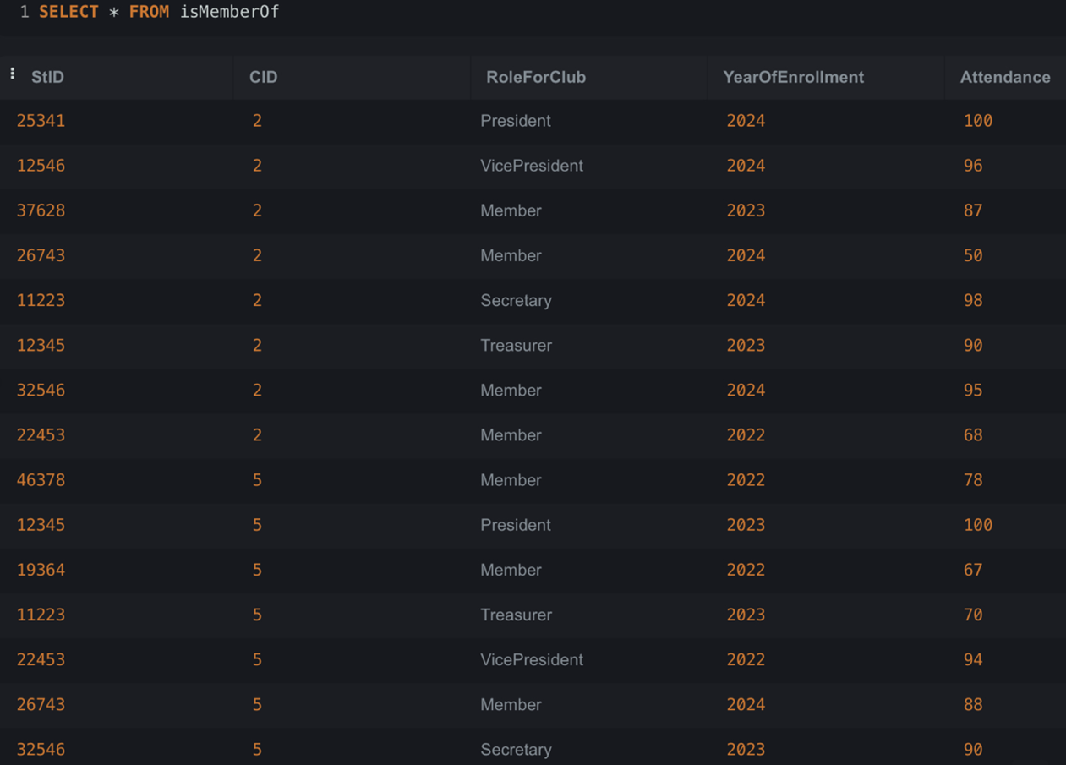
1 student can be a member of more than 1 club. 1 club needs at least 6 students to be created.
- participatesIn
CREATE TABLE participatesIn(
StID CHAR (5) NOT NULL,
EID CHAR NOT NULL,
RoleForEvent VARCHAR (15) NOT NULL,
PRIMARY KEY (StID,EID),
FOREIGN KEY (StID) REFERENCES Students (StID) ON DELETE CASCADE ON UPDATE RESTRICT,
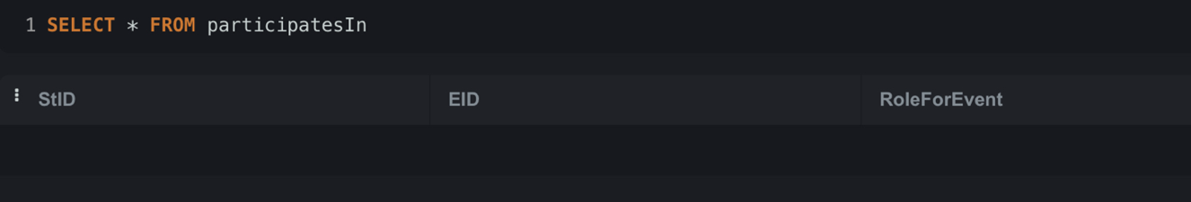
FOREIGN KEY (EID) REFERENCES Event (EID) ON DELETE CASCADE ON UPDATE RESTRICT);

INSERT INTO participatesIn(StID, EID, RoleForEvent)VALUES
('32546','a','Organizator'),
('26743','a','Participant'),
('19364','a','Participant'),
('12345','a','Participant'),
('25341','a','Participant'),
('46378','a','Participant'),
('11223','a','Participant'),
('46378','c','Participant'),
('26743','c','Participant'),
('11223','c','Organizator'),
('22453','c','Participant'),
('37628','c','Participant'),
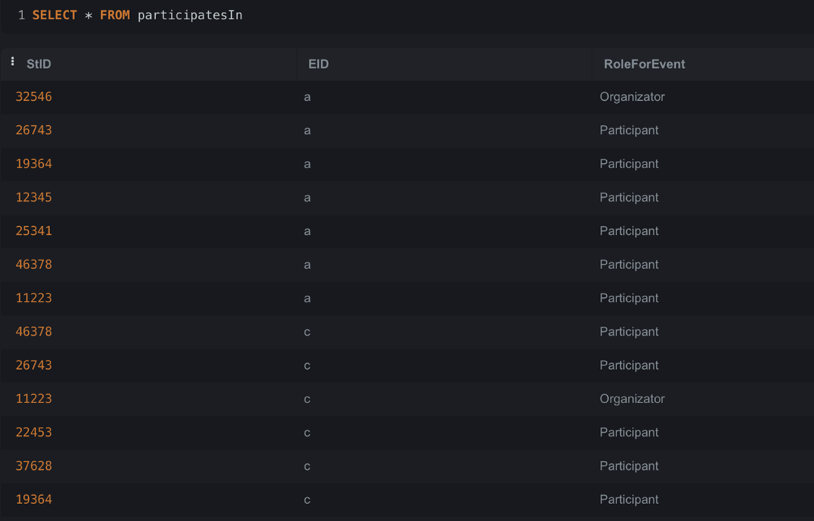
('19364','c','Participant');
1 student can participate in more than 1 event. 1 event needs at least 6 students to happen.
NORMALIZATION
Let’s suppose that there were dependencies in the Student table where StID is primary key and we had to normalize it. It would look like this:
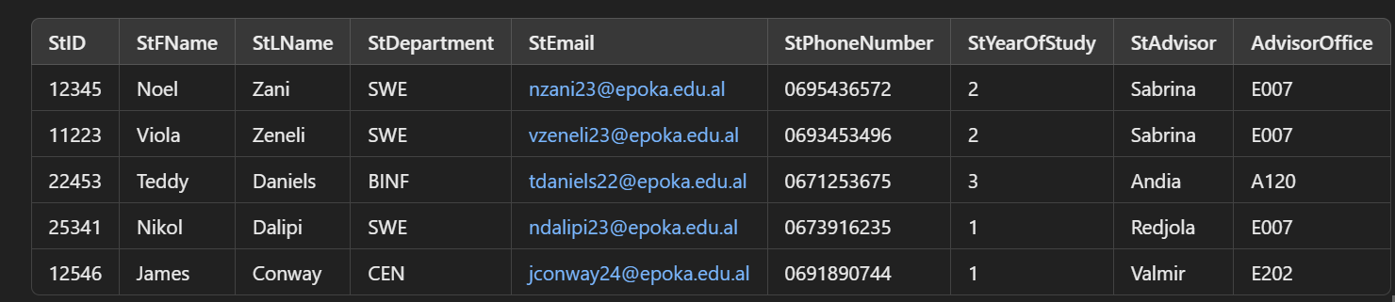
From the table, the following dependencies can be identified:
- StID → StFName, StLName, StDepartment, StEmail, StPhoneNumber, StYearOfStudy, StAdvisor (FKD)
- StAdvisor → AdvisorOffice(TKD)

The table is already on the 1st form (No multivalues).
2nd form(No PKD).
3rd form(No TKD) we would have these tables:
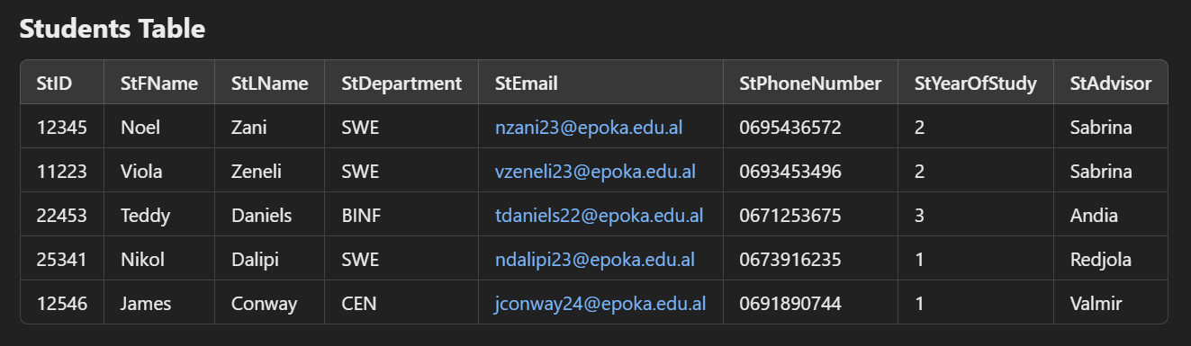
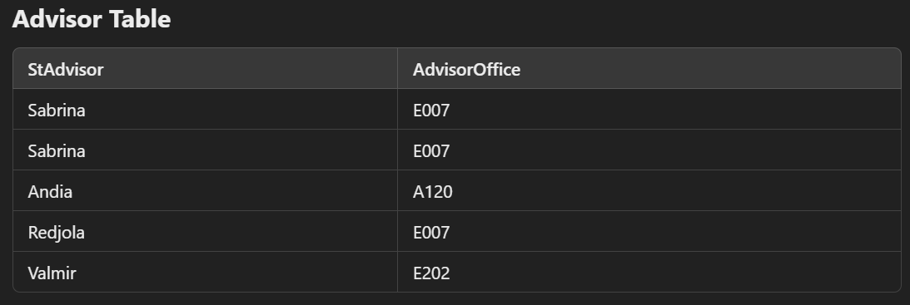
In this table StAdvisor would be a primary key.
- Club

CREATE TABLE Club(
CID INT PRIMARY KEY,
CName VARCHAR(100) NOT NULL,
CFoundDate DATE NOT NULL,
CNrOfParticipants INT NOT NULL
);

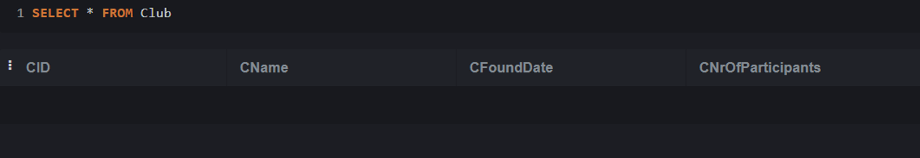

INSERT INTO Club(CID, CName, CFoundDate, CNrOfParticipants)VALUES
(1,'Film Club','15-09-2018',480),
(2,'Young Talent Music Club','09-10-2020',340),
(3,'Sports Club','25-19-2015',675),
(4,'Google Developer Club','12-10-2019',1198),
(5,'Future Engineers Club','23-11-2018',956),
(6,'Volunteer Club','28-09-2016',1043),
(7,'Diplomacy Club','17-10-2023',180),
(8,'Young Economists Network','29-09-2022',215),
(9,'Finance Club','16-11-2017',940),
(10,'Programming Club','21-10-2016',1062),
(11,'Electronics Club','13-11-2018',867),
(12,'Innovators Club','29-11-2022',657),
(13,'Marketing Zone Club','12-10-2019',1035),
(14,'Sensitive Society Club','05-10-2023',726),
(15,'Iustitia Club','23-11-2018',740),
(16,'Ncep Club','16-10-2022',320),
(17,'Multimedia Club','21-10-2017',527),
(18,'Book Lovers Club','15-09-2021',614),
(19,'Theater Club','15-09-2021',462),
(20,'Podcast And Journal Club','24-10-2024',315),
(21,'Human Rights Defender Club','19-10-2024',214),
(22,'Art Club','20-10-2017',1010),
(23,'Womens Leadership Club','27-10-2021',826),
(24,'Robotic Club','02-11-2024',769),
(25,'Outdoors Club','31-10-2018',942);
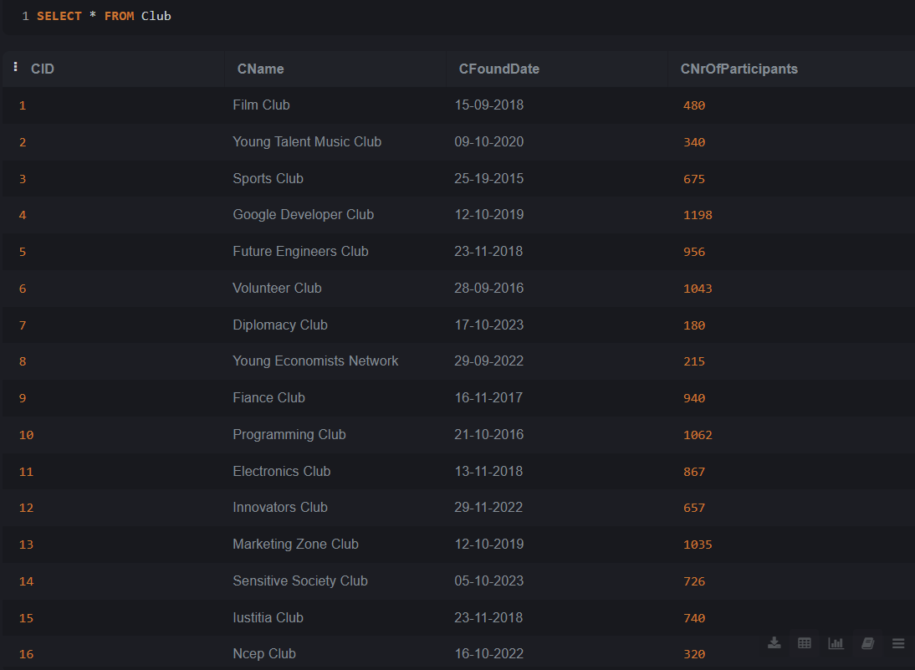
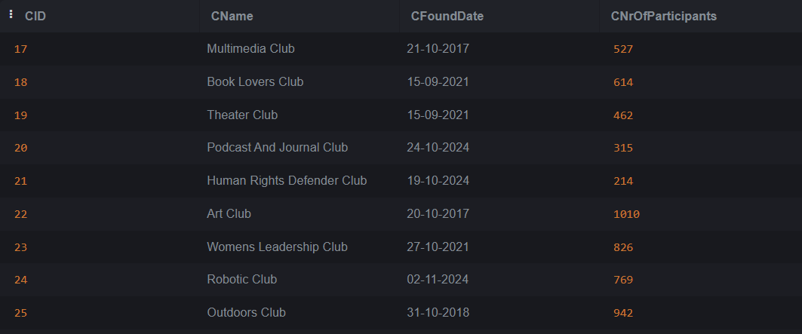
From the table, the dependency can be identified as:
CID --> CName, CFoundDate, CNrOfParticipants (FKD)

- Event

CREATE TABLE Event(
EID CHAR PRIMARY KEY,
EName VARCHAR(100) NOT NULL,
EDATE DATE NOT NULL,
ELocation VARCHAR(100) NOT NULL,
EDescription VARCHAR(250) NOT NULL,
ESponsor VARCHAR(100),
CID INT,
FOREIGN KEY (CID) REFERENCES Club(CID) ON DELETE CASCADE ON UPDATE RESTRICT
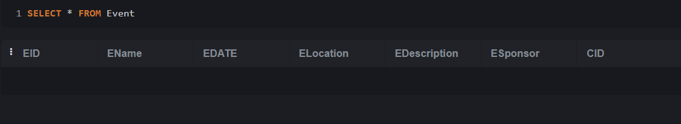
);
INSERT INTO Event(EID, EName, EDate, ELocation, EDescription, ESponsor, CID) VALUES
('a','Movie Screening: The Truman Show','19-01-2023','Conference Hall','Movie Screening next week',NULL,1),
('b','Art Week','23-03-2023','Epoka Campus','Showcasing local artists',NULL,22),
('c','Spring Fest','24-05-2023','Epoka Campus','Annual University Festival','Epoka University',2),
('d','Club Fest','04-11-2024','Epoka Campus','Get to know all the clubs offered at Epoka','x bank',2),
('e','DevFest','22-12-2024','Pyramid of Tirana','A meetup for tech enthusiasts','Google',4),
('f','Football League','15-10-2024','Soccer Field','All interested should apply for the teams',NULL,3),
('g','Poetry Competition','15-03-2023','A101','Call for all interested',NULL,22);

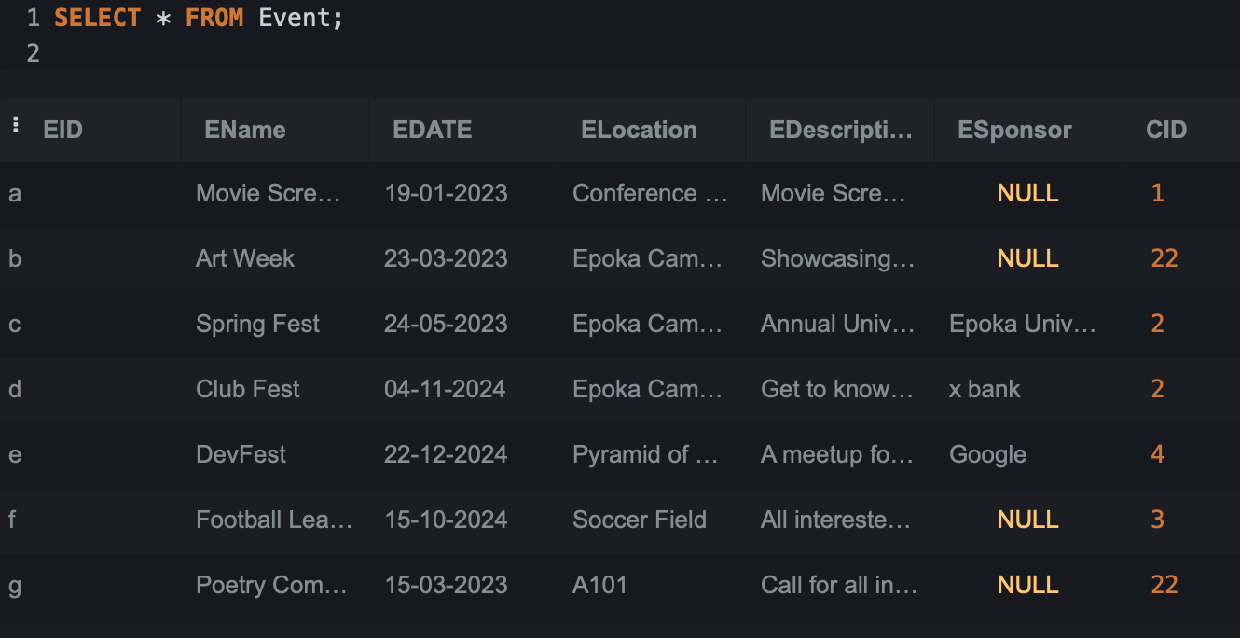
From the table, the dependency can be identified as:
EID --> EName, EDate, ELocation, EDescription,ESponsor,CID (FKD)
In both table there’s a Full Key Depndency so we don’t have to do Normalization

Let’s suppose I want to delete the last row of the table Event. In that case I would write:
DELETE FROM Event
WHERE EID='g';

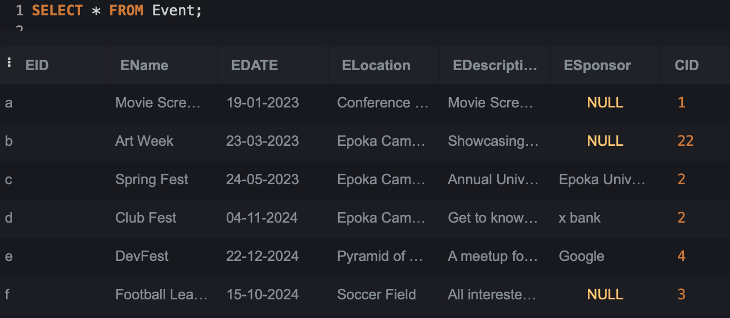

We see that the last row is deleted from the table

- DOSEmployee
CREATE TABLE DOSEmployee (
DID VARCHAR(4) PRIMARY KEY,
DFirstName VARCHAR(25) NOT NULL,
DLastName VARCHAR(25)NOT NULL,
DRole VARCHAR(50) NOT NULL,
DEmail VARCHAR(77) NOT NULL,
DOffice CHAR(4)NOT NULL,
DOfficePhone INT
);

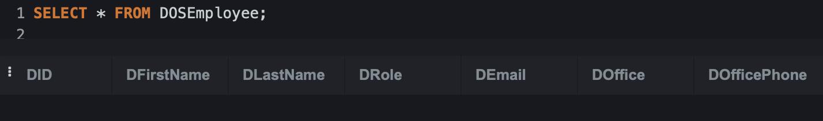

INSERT INTO DOSEmployee (DID, DFirstName, DLastName, Drole, DEmail, DOffice, DOfficePhone) VALUES
('AA01','Sadullah', 'Yilmaz', 'Dean of Students', 'syilmaz@epoka.edu.al', 'A001', 111222333),
('AB02', 'Naida', 'Ertekin', 'Vice Dean of Students', 'nertekin@epoka.edu.al', 'E005', 123345567),
('AC03', 'Jonida', 'Sota', 'Coordinator', 'jsota@epoka.edu.al', 'E008', 432578975),
('AD04', 'Kelima', 'Hima', 'Career Planning and Alumni Specialist', 'khima@epoka.edu.al', 'D104', 754231821),
('AE05', 'Jona', 'Kaso', 'Student Clubs and Activities Specialist', 'jkaso@epoka.edu.al', 'E002', 512721910);

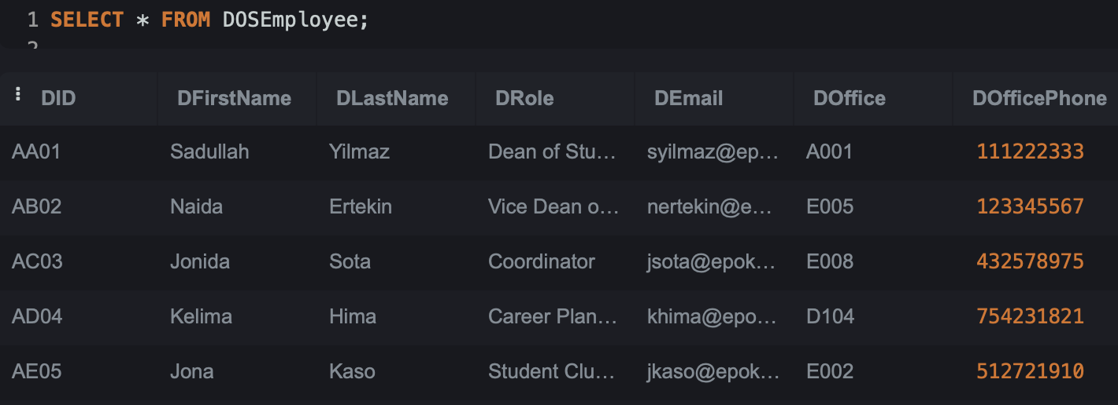
From the table, the dependency can be identified as:
DID -> DFirstName, DLastName, Drole, DEmail, DOffice, DOfficePhone (FKD)

- Report

CREATE TABLE Report(
RAcademicYear CHAR(9) PRIMARY KEY,
RDateSubmitted DATE NOT NULL,
RNrOfEvents INT NOT NULL,
RNrOfClubs INT NOT NULL,
DID VARCHAR(4) NOT NULL,
FOREIGN KEY (DID) REFERENCES DOSEmployee ON DELETE CASCADE ON UPDATE RESTRICT );

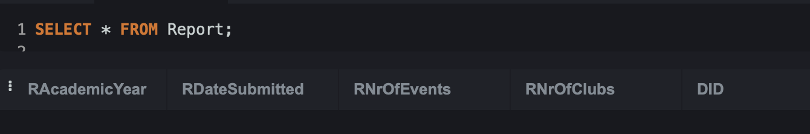

INSERT INTO Report(RAcademicYear, RDateSubmitted, RNrOfEvents, RNrOfClubs, DID) VALUES
('2017-2018', '07/27/2018', 34, 10, 'AB02'),
('2018-2019', '08/26/2019', 25, 13, 'AA01'),
('2019-2020', '08/06/2020', 33, 20, 'AC03'),
('2021-2022', '07/21/2022', 26, 22, 'AE05'),
('2022-2023', '01/20/2023', 45, 24, 'AD04');

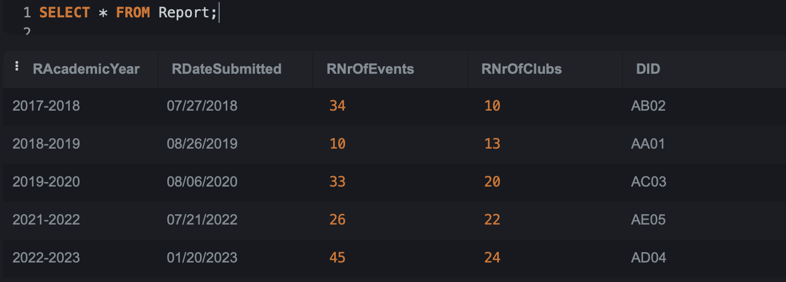

From the table, the dependency can be identified as:
RAcademicYear -> RDateSubmitted, RNrOfEvents, RNrOfClubs, DID (FKD)
In both tables, there is Full Key Dependency, so we don’t have to do normalization.

UPDATE EXAMPLE :

UPDATE Report
SET RNrOfEvents=10
WHERE RNrOfEvents=26;

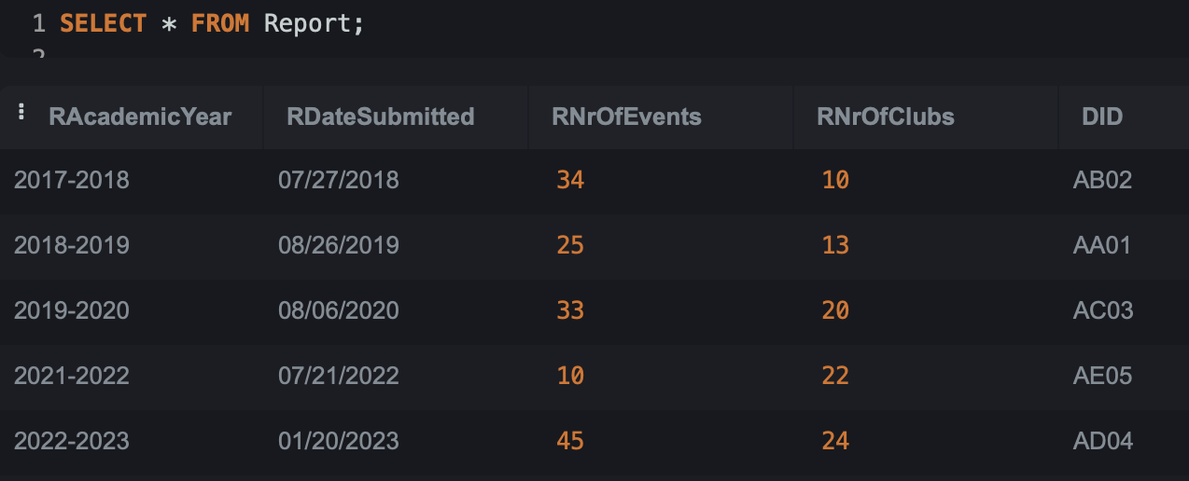
INDEX
To improve query performance, we will create indexes for all columns in each table.

-- Indexes for Advisor
CREATE INDEX idx_advisor_aid ON Advisor(AID);
CREATE INDEX idx_advisor_afirstname ON Advisor(AFirstName);
CREATE INDEX idx_advisor_alastname ON Advisor(ALastName);
CREATE INDEX idx_advisor_aemail ON Advisor(AEmail);
CREATE INDEX idx_advisor_adepartment ON Advisor(ADepartment);
CREATE INDEX idx_advisor_aoffice ON Advisor(AOffice);
CREATE INDEX idx_advisor_aofficephone ON Advisor(AOfficePhone);

-- Indexes for Supervises
CREATE INDEX idx_supervises_aid ON Supervises(AID);
CREATE INDEX idx_supervises_cid ON Supervises(CID);
CREATE INDEX idx_supervises_startyear ON Supervises(StartYear);
CREATE INDEX idx_supervises_endyear ON Supervises(EndYear);

-- Indexes for Students
CREATE INDEX idx_students_stid ON Students(StID);
CREATE INDEX idx_students_stfname ON Students(StFName);
CREATE INDEX idx_students_stlname ON Students(StLName);
CREATE INDEX idx_students_stdepartment ON Students(StDepartment);
CREATE INDEX idx_students_stemail ON Students(StEmail);
CREATE INDEX idx_students_stphonenumber ON Students(StPhoneNumber);
CREATE INDEX idx_students_styearofstudy ON Students(StYearOfStudy);

-- Indexes for isMemberOf
CREATE INDEX idx_ismemberof_stid ON isMemberOf(StID);
CREATE INDEX idx_ismemberof_cid ON isMemberOf(CID);
CREATE INDEX idx_ismemberof_roleforclub ON isMemberOf(RoleForClub);
CREATE INDEX idx_ismemberof_yearofenrollment ON isMemberOf(YearOfEnrollment);
CREATE INDEX idx_ismemberof_attendance ON isMemberOf(Attendance);

-- Indexes for participatesIn
CREATE INDEX idx_participatesin_stid ON participatesIn(StID);
CREATE INDEX idx_participatesin_eid ON participatesIn(EID);
CREATE INDEX idx_participatesin_roleforevent ON participatesIn(RoleForEvent);

-- Indexes for Club
CREATE INDEX idx_club_cid ON Club(CID);
CREATE INDEX idx_club_cname ON Club(CName);
CREATE INDEX idx_club_cfounddate ON Club(CFoundDate);
CREATE INDEX idx_club_cnrofparticipants ON Club(CNrOfParticipants);

-- Indexes for Event
CREATE INDEX idx_event_eid ON Event(EID);
CREATE INDEX idx_event_ename ON Event(EName);
CREATE INDEX idx_event_edate ON Event(EDate);
CREATE INDEX idx_event_elocation ON Event(ELocation);
CREATE INDEX idx_event_edescription ON Event(EDescription);
CREATE INDEX idx_event_esponsor ON Event(ESponsor);
CREATE INDEX idx_event_cid ON Event(CID);

-- Indexes for DOSEmployee
CREATE INDEX idx_dosemployee_did ON DOSEmployee(DID);
CREATE INDEX idx_dosemployee_dfirstname ON DOSEmployee(DFirstName);
CREATE INDEX idx_dosemployee_dlastname ON DOSEmployee(DLastName);
CREATE INDEX idx_dosemployee_drole ON DOSEmployee(DRole);
CREATE INDEX idx_dosemployee_demail ON DOSEmployee(DEmail);
CREATE INDEX idx_dosemployee_doffice ON DOSEmployee(DOffice);
CREATE INDEX idx_dosemployee_dofficephone ON DOSEmployee(DOfficePhone);

-- Indexes for Report
CREATE INDEX idx_report_racademicyear ON Report(RAcademicYear);
CREATE INDEX idx_report_rdatesubmitted ON Report(RDateSubmitted);
CREATE INDEX idx_report_rnrofevents ON Report(RNrOfEvents);
CREATE INDEX idx_report_rnrofclubs ON Report(RNrOfClubs);
CREATE INDEX idx_report_did ON Report(DID);

List of all final tables (to better understand how queries work) :

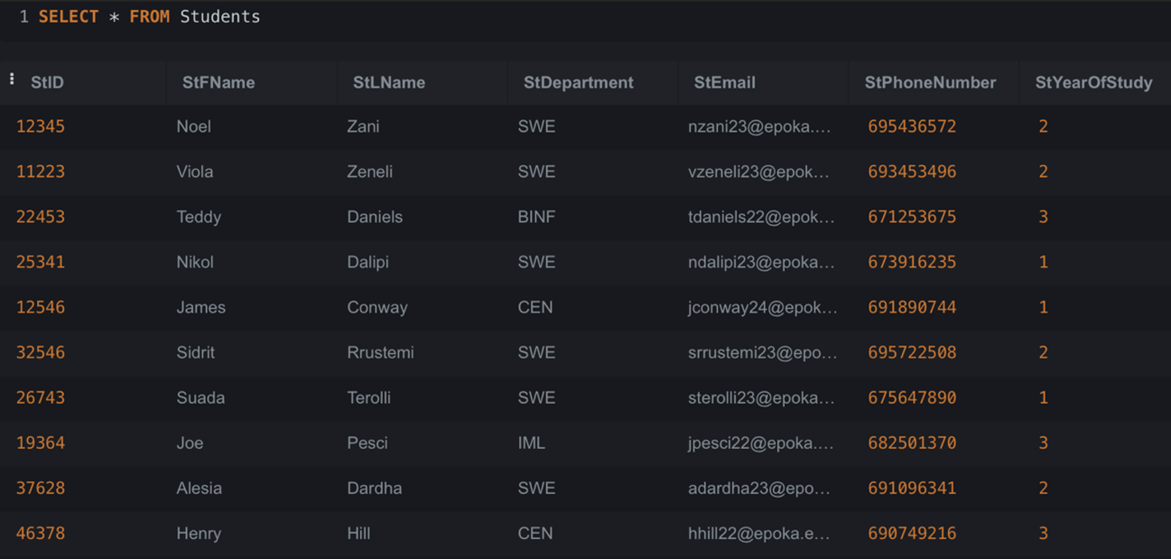

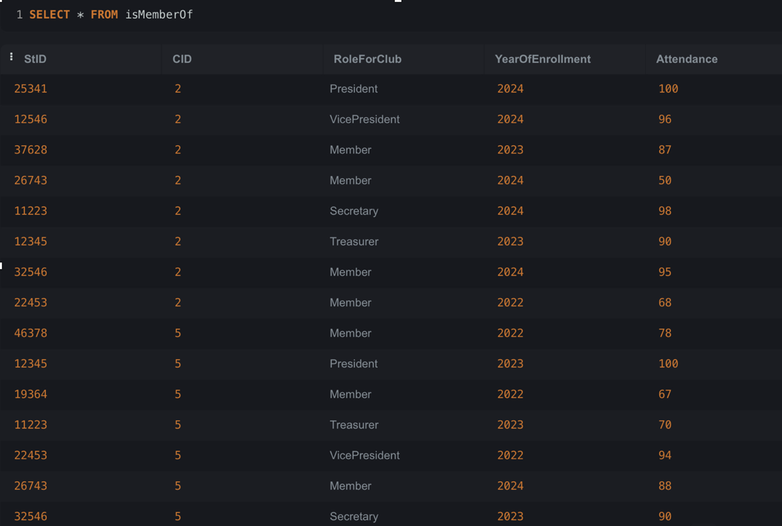

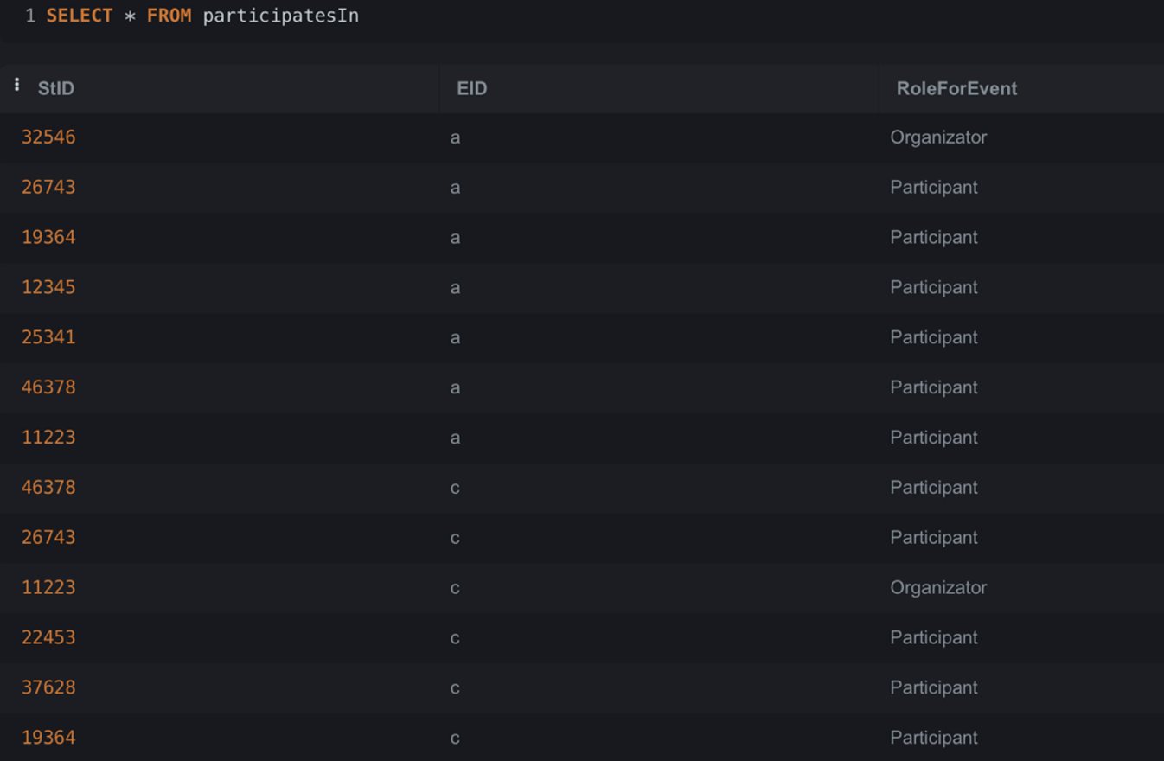

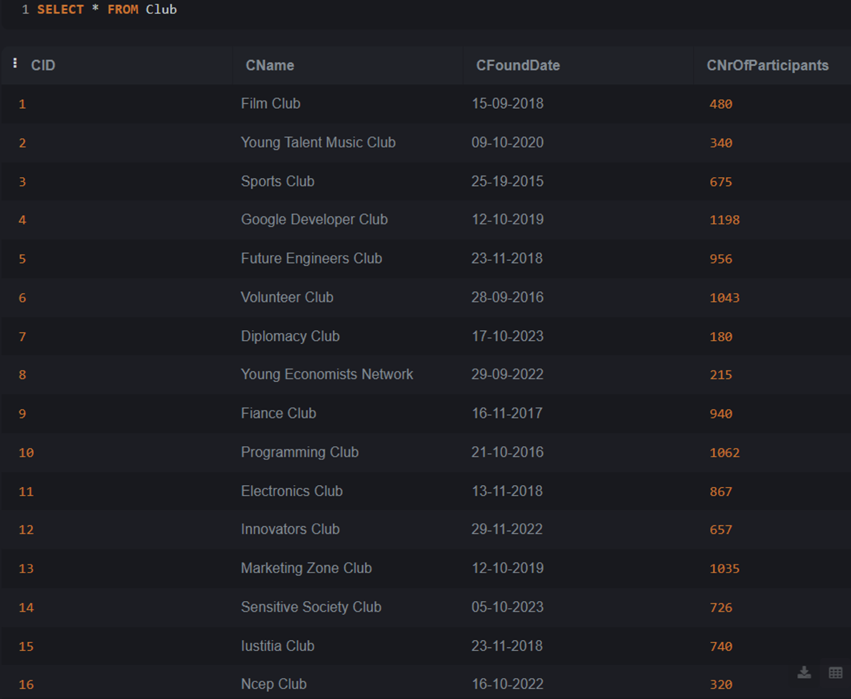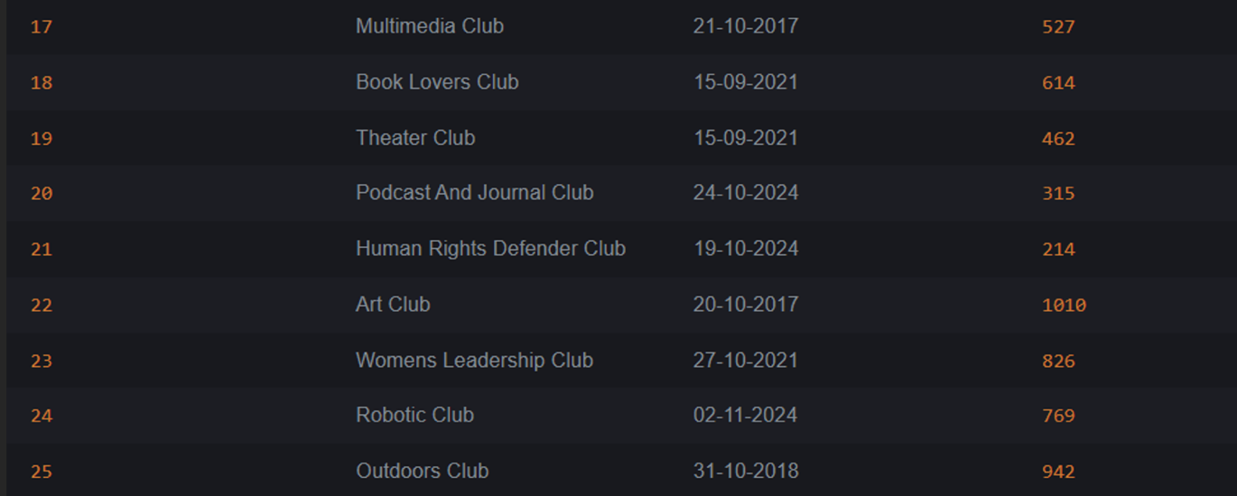

25 MANAGERIAL QUERIES :

- Students with the role president(in isMemberOf) for any of the clubs.

SELECT s.StFName AS FirstName, s.StLName AS LastName, c.CName AS ClubName
FROM Students s, isMemberOf im, Club c
WHERE s.StID = im.StID AND im.CID = c.CID AND im.RoleForClub = 'President';

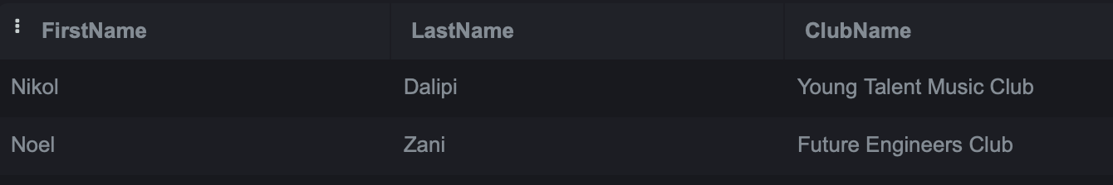

- Clubs with More Than 500 Participants Ordered by Name

SELECT CName AS ClubName, CNrOfParticipants AS Participants
FROM Club
WHERE CNrOfParticipants > 500
ORDER BY CName ASC;

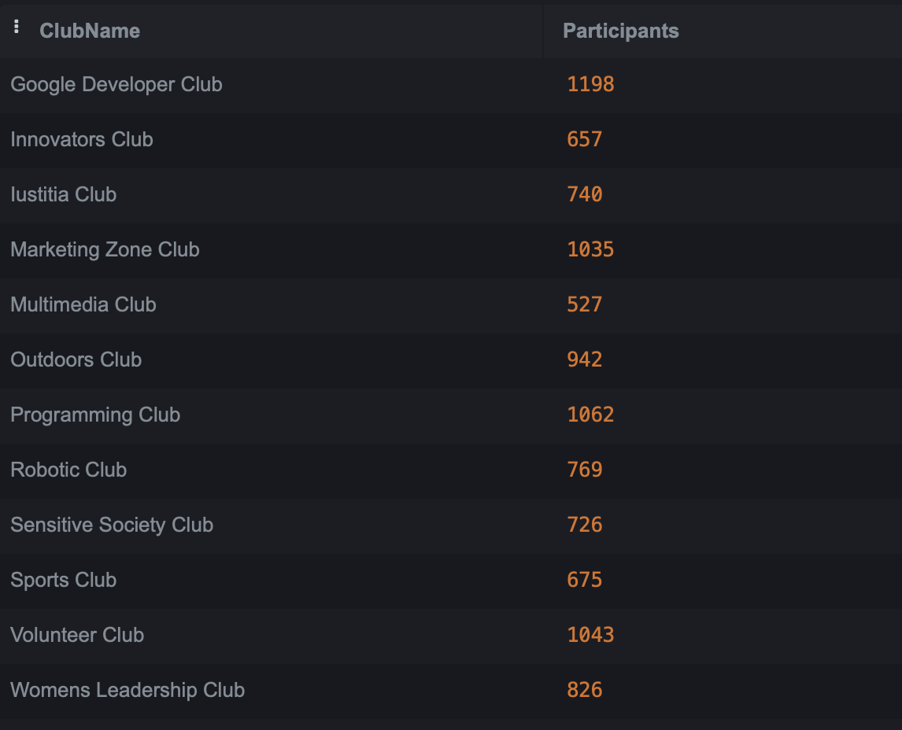

- Events Organized by Clubs Found Before 2020 ordered from latest event date to newest event date.

SELECT e.EName AS EventName, c.CName AS ClubName, e.EDate AS EventDate
FROM Event e, Club c
WHERE e.CID = c.CID AND c.CFoundDate < '2020-01-01'
ORDER BY e.EDate DESC;

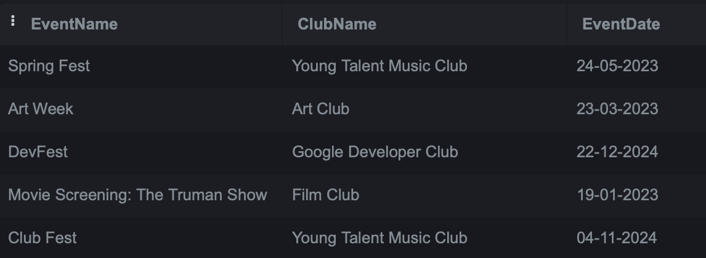

- Average Attendance for Each Role in Clubs

SELECT RoleForClub AS Role, AVG(Attendance) AS AverageAttendance
FROM isMemberOf
GROUP BY RoleForClub;

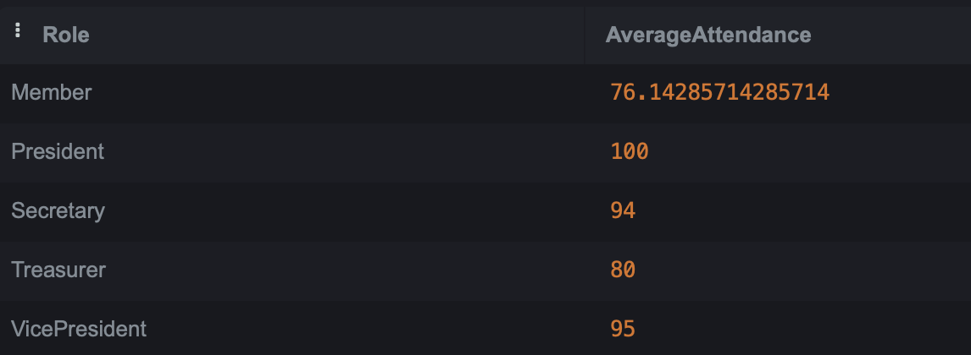

- Advisors and the clubs they supervise

SELECT a.AFirstName AS FirstName, a.ALastName AS LastName, c.CName AS ClubName
FROM Advisor a,Supervises s,Club c
where a.AID = s.AID and s.CID = c.CID
ORDER BY a.AFirstName ASC;

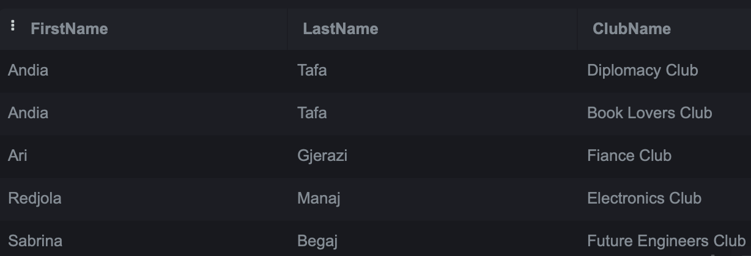

- Events with more than 6 participants

SELECT e.EName AS EventName, COUNT(pi.StID) AS TotalParticipants
FROM Event e, participatesIn pi
where e.EID = pi.EID
GROUP BY e.EName
HAVING COUNT(pi.StID) > 6;

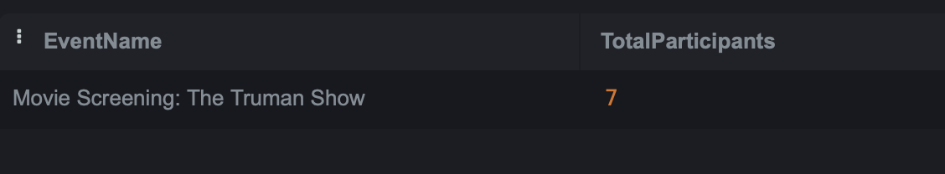

- Top 3 Clubs with the Most Participants and their Supervisors

SELECT c.CName AS ClubName, c.CNrOfParticipants AS TotalParticipants,
a.AFirstName AS SupervisorFirstName, a.ALastName AS SupervisorLastName
FROM Club c, Supervises s,Advisor a
where c.CID = s.CID and s.AID = a.AID
ORDER BY c.CNrOfParticipants DESC
LIMIT 3;

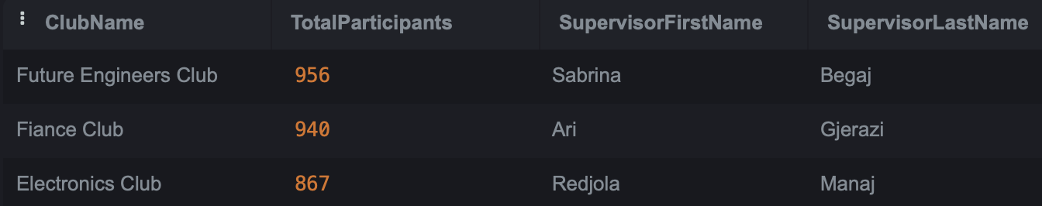

- Student with highest attendance for each club (that has participants)

SELECT im.CID AS ClubID, c.CName AS ClubName, im.StID AS StudentID,
s.StFName AS StudentFirstName, s.StLName AS StudentLastName,
im.Attendance AS HighestAttendance
FROM isMemberOf im
JOIN Students s ON im.StID = s.StID
JOIN Club c ON im.CID = c.CID
WHERE im.Attendance = (SELECT MAX(im2.Attendance) FROM isMemberOf im2
WHERE im2.CID = im.CID)
ORDER BY c.CName;

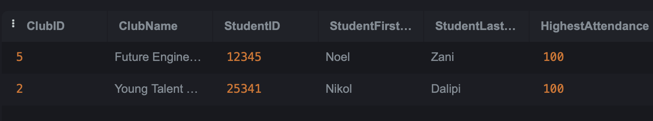
- Clubs with events sponsored by Google

SELECT c.CName AS ClubName, e.EName AS EventName, e.EDate AS EventDate
FROM Club c ,Event e
WHERE c.CID = e.CID and e.ESponsor LIKE '%Google%'
ORDER BY e.EDate DESC;

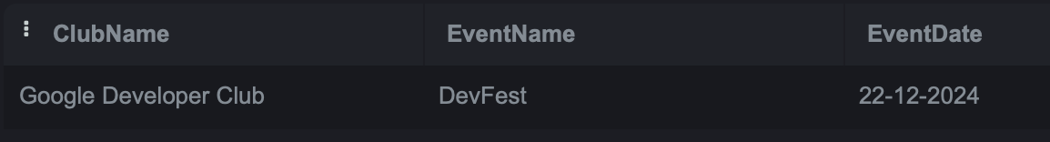

- Students that participate in clubs with above-average number of participants

SELECT s.StFName AS StudentFirstName, s.StLName AS StudentLastName, c.CName AS ClubName
FROM Students s
JOIN isMemberOf im ON s.StID = im.StID
JOIN Club c ON im.CID = c.CID
WHERE c.CNrOfParticipants > (SELECT AVG(CNrOfParticipants) FROM Club)
ORDER BY s.StFName, s.StLName;

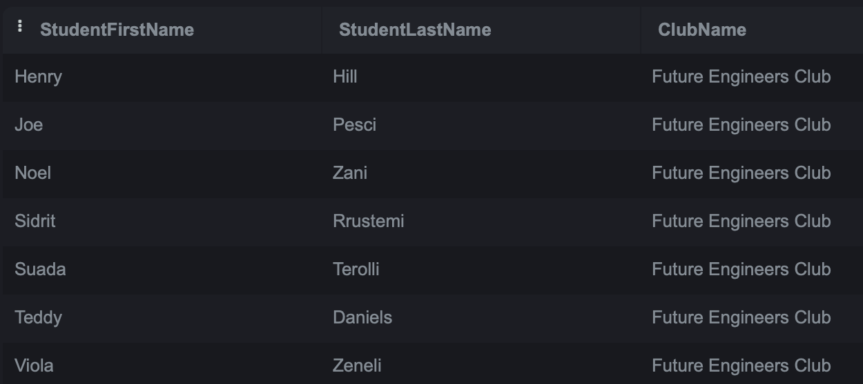

- Students participating in events organized by the clubs they are member of

SELECT s.StID AS StudentID, s.StFName AS StudentFirstName, s.StLName AS StudentLastName, e.EName AS EventName
FROM Students s
JOIN participatesIn pi ON s.StID = pi.StID
JOIN Event e ON pi.EID = e.EID
WHERE e.CID IN (
SELECT im.CID
FROM isMemberOf im
WHERE im.StID = s.StID
)
ORDER BY s.StFName;
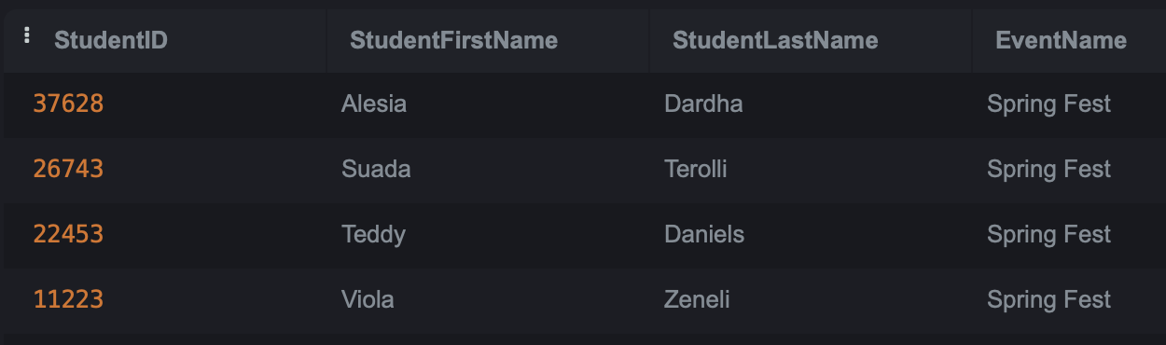

- List all student departments

SELECT DISTINCT StDepartment AS Department
FROM Students;

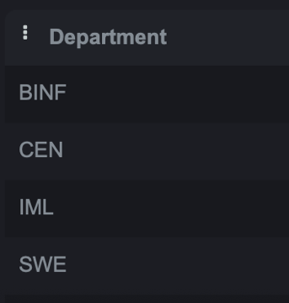

- Students in clubs with more participants than average number of club participants

SELECT s.StID, s.StFName, s.StLName, c.CName AS ClubName
FROM Students s
JOIN isMemberOf im ON s.StID = im.StID
JOIN Club c ON im.CID = c.CID
WHERE c.CNrOfParticipants > (
SELECT AVG(CNrOfParticipants)
FROM Club
);

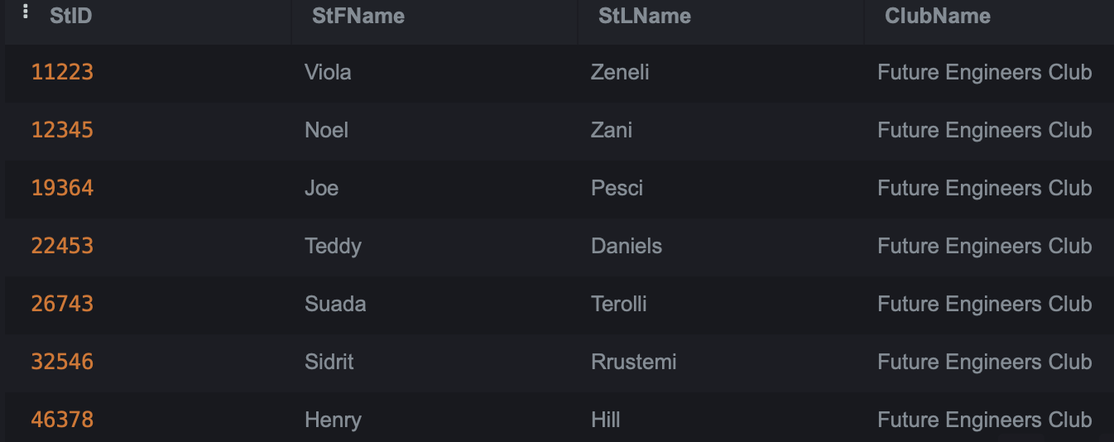

- Clubs with or without events

SELECT c.CID AS ClubID, c.CName AS ClubName, e.EName AS EventName
FROM Club c
LEFT JOIN Event e ON c.CID = e.CID;

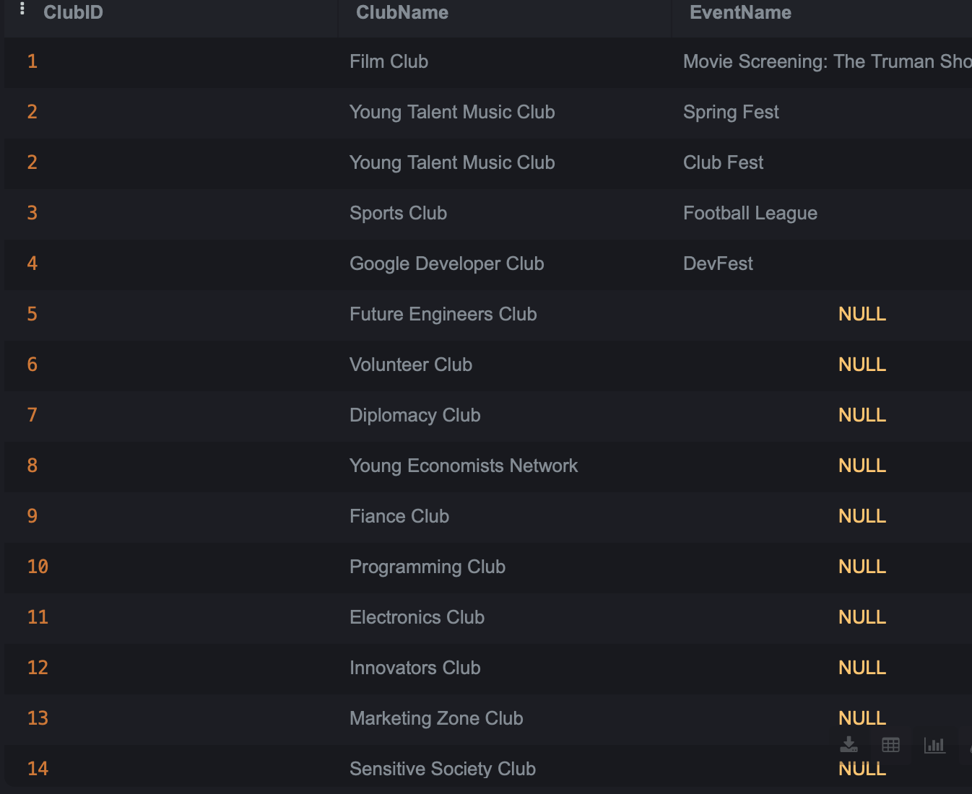
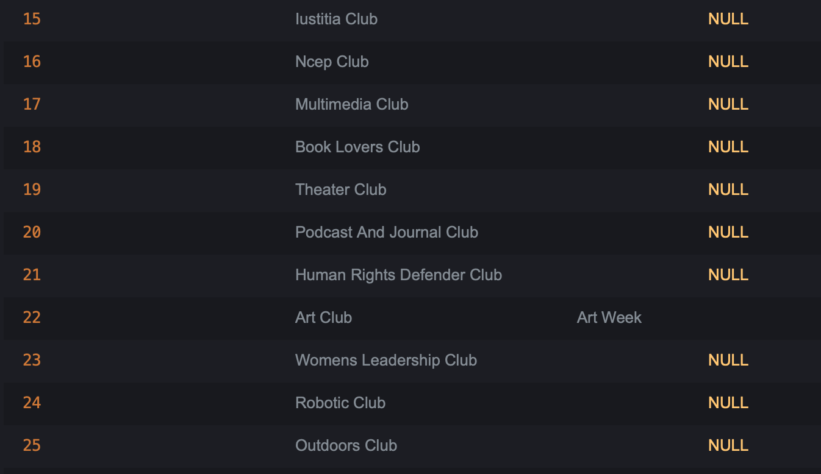

- Students who are both event participants and club members

SELECT s.StID AS StudentID, s.StFName AS FirstName, s.StLName AS LastName
FROM Students s
JOIN participatesIn pi ON s.StID = pi.StID
INTERSECT
SELECT s.StID, s.StFName, s.StLName
FROM Students s
JOIN isMemberOf im ON s.StID = im.StID;

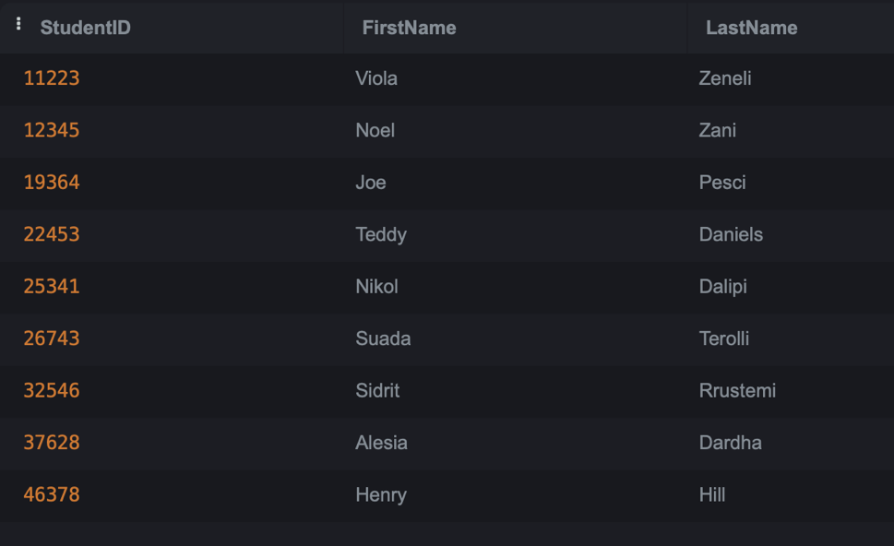

- Clubs that have members but do not host events
(can be done also with minus keyword)

SELECT DISTINCT c.CID AS ClubID, c.CName AS ClubName
FROM Club c
JOIN isMemberOf im ON c.CID = im.CID
LEFT JOIN Event e ON c.CID = e.CID
WHERE e.EID IS NULL;

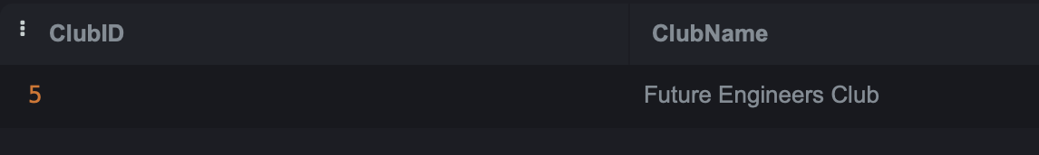

- Total members and average attendance for each club (that has members) sorted by average attendance in descending order

SELECT c.CID AS ClubID, c.CName AS ClubName, COUNT(im.StID) AS TotalMembers,
AVG(im.Attendance) AS AvgAttendance
FROM Club c
JOIN isMemberOf im ON c.CID = im.CID
GROUP BY c.CID
ORDER BY AvgAttendance DESC;
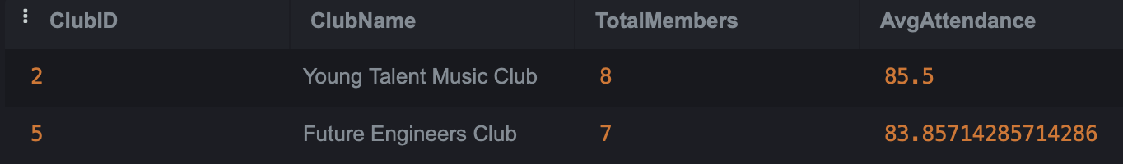

- Total events organized by each club

SELECT c.CID as ClubID,c.CName AS ClubName, COUNT(e.EID) AS TotalEvents
FROM Club c
LEFT JOIN Event e ON c.CID = e.CID
GROUP BY c.CID
ORDER BY TotalEvents DESC;

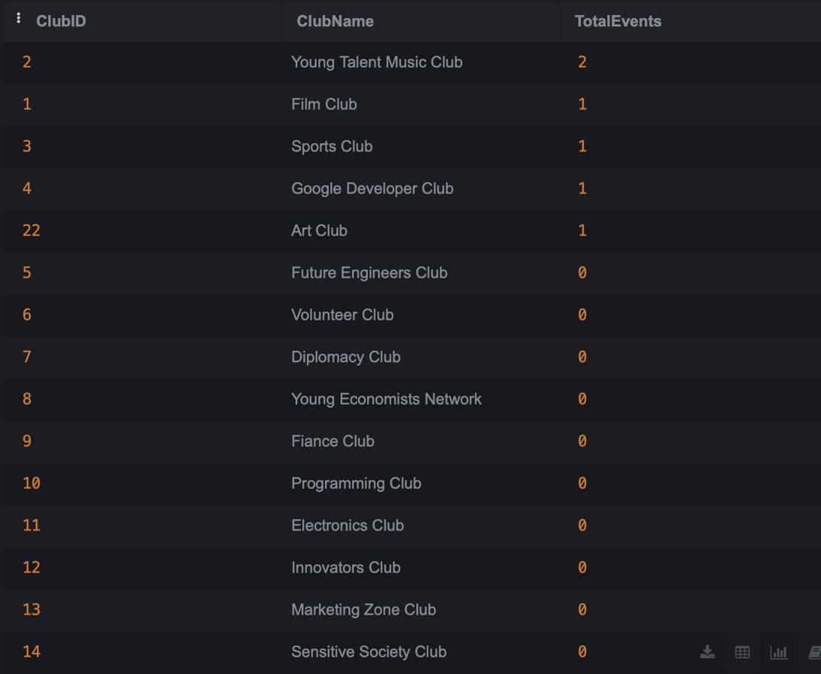
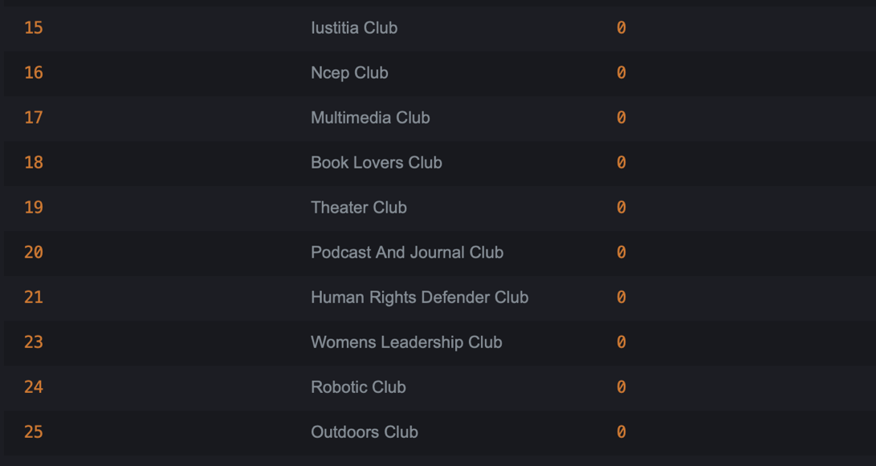

- Students in Year 1 or Year 2, along with their club roles and respective club names

SELECT s.StID AS StudentID, s.StFName AS FirstName, s.StLName AS LastName, im.RoleForClub AS Role, c.CName AS ClubName
FROM Students s
JOIN isMemberOf im ON s.StID = im.StID
JOIN Club c ON im.CID = c.CID
WHERE s.StYearOfStudy = 1
UNION
SELECT s.StID, s.StFName, s.StLName, im.RoleForClub, c.CName
FROM Students s
JOIN isMemberOf im ON s.StID = im.StID
JOIN Club c ON im.CID = c.CID
WHERE s.StYearOfStudy = 2
ORDER BY Role;

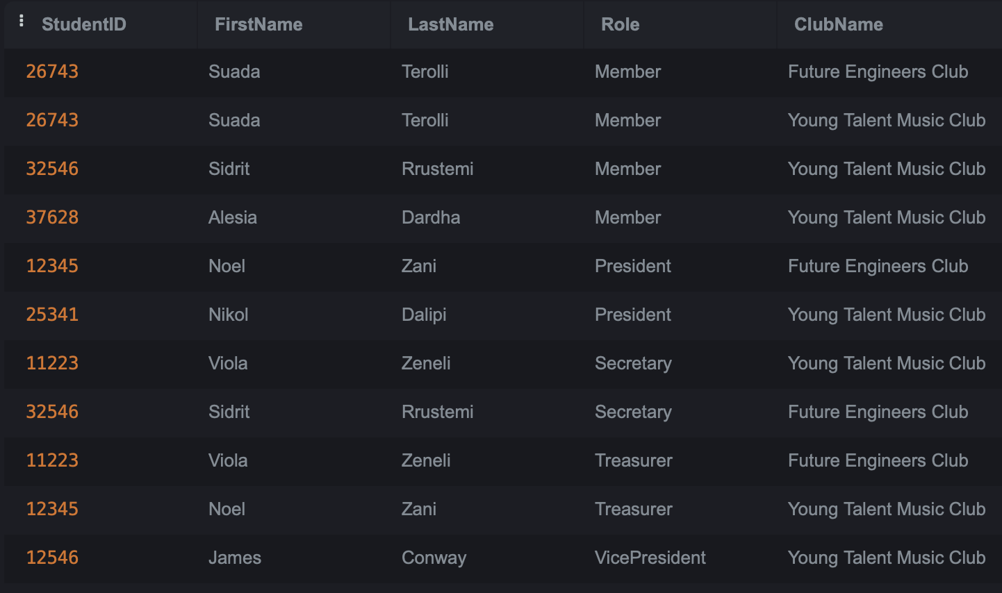

- Show clubs and their number of participants for active(more than 300 participants) clubs (using a view)

CREATE VIEW ActiveClubs AS
SELECT CID, CName, CNrOfParticipants
FROM Club
WHERE CNrOfParticipants > 300;

SELECT *
FROM ActiveClubs ;

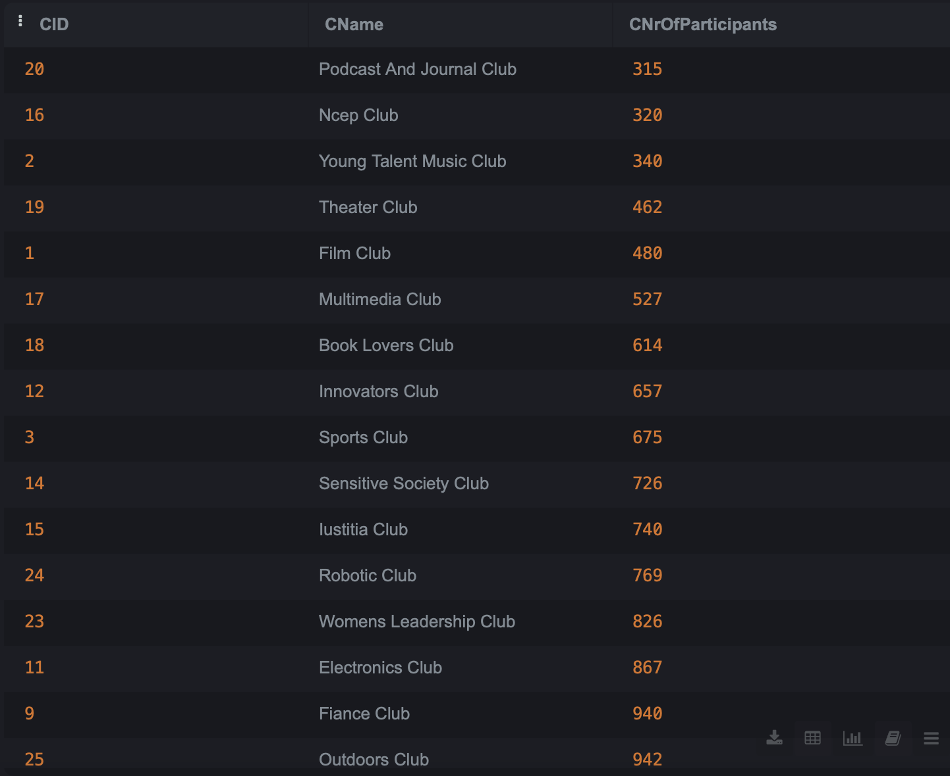
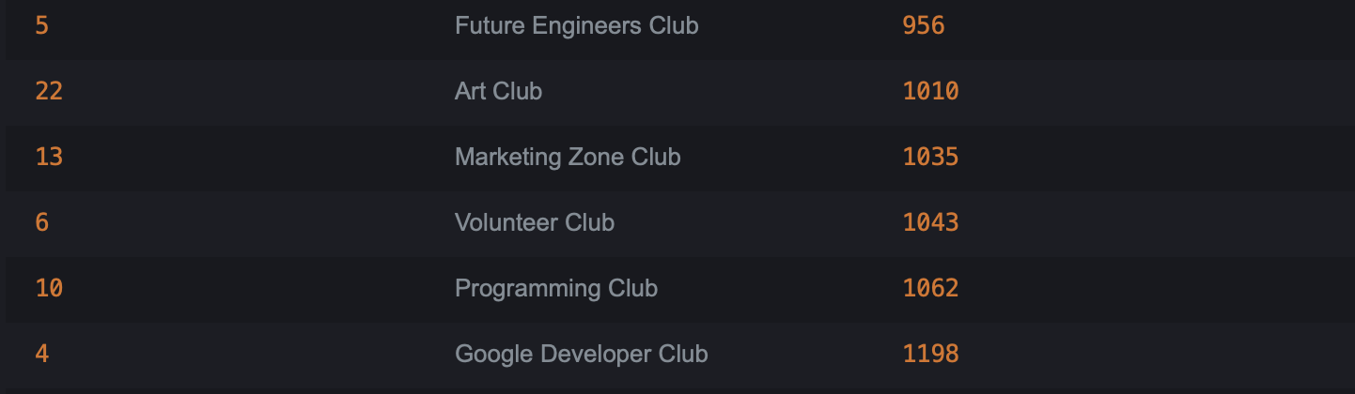

- Retrieve Reports submitted by each DOSEmployee

SELECT
CONCAT(D.DFirstName, ' ', D.DLastName) AS EmployeeName,
R.RAcademicYear AS AcademicYear,
R.RDateSubmitted AS DateSubmitted,
R.RNrOfEvents AS NumberOfEvents,
R.RNrOfClubs AS NumberOfClubs
FROM Report R, DOSEmployee D
where R.DID = D.DID
ORDER BY D.DFirstName;

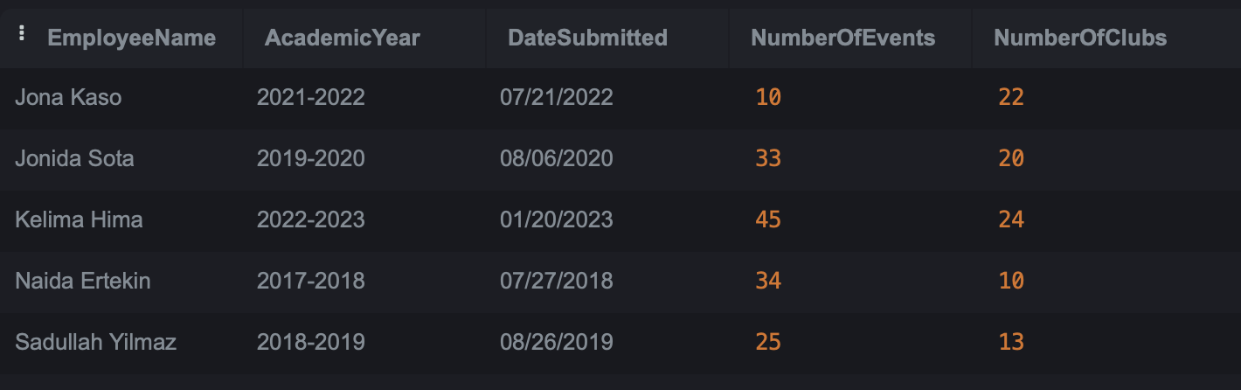

- Retrieve advisors overseeing the most clubs

SELECT
CONCAT(A.AFirstName, ' ', A.ALastName) AS AdvisorName,
COUNT(S.CID) AS NumberOfClubs
FROM Advisor A, Supervises S
where A.AID = S.AID
GROUP BY A.AID
ORDER BY NumberOfClubs DESC;

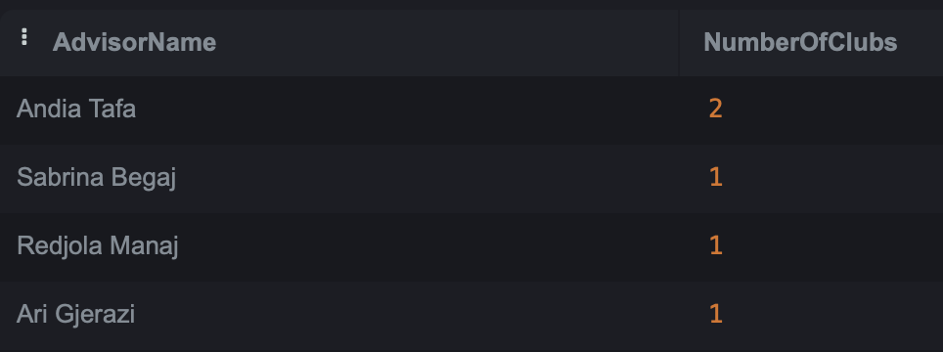

- Retrieve events which had sponsors sorted from newest to oldest

SELECT E.EName AS EventName, E.EDate AS EventDate, E.ELocation AS Location, E.ESponsor AS Sponsor
FROM Event E
WHERE E.ESponsor IS NOT NULL
ORDER BY E.EDate DESC;

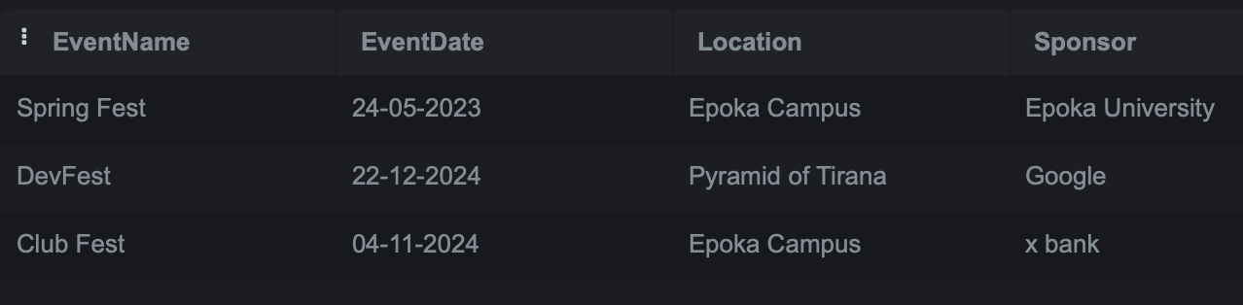

- Retrieve all club names that have no advisor
SELECT C.CName AS ClubName
FROM Club C
LEFT JOIN Supervises S ON C.CID = S.CID
WHERE S.AID IS NULL
ORDER BY C.CID;
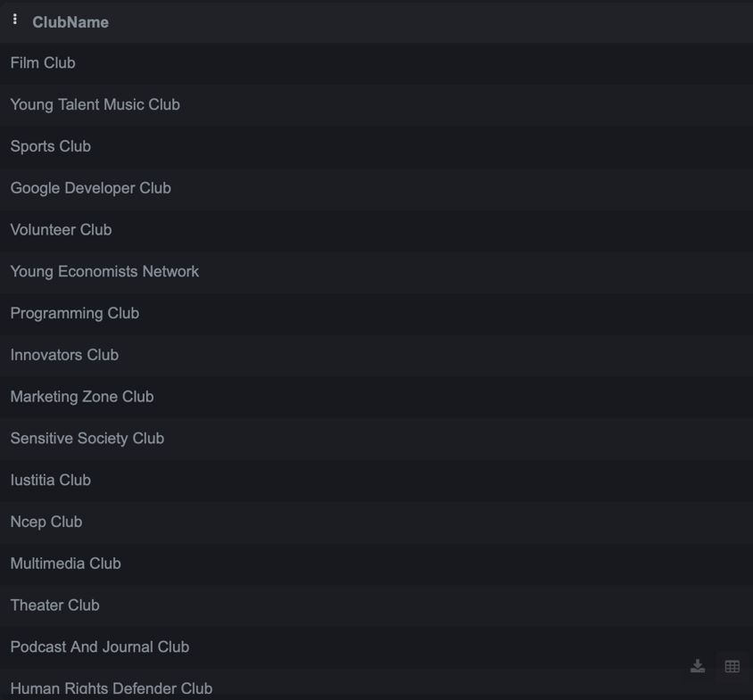
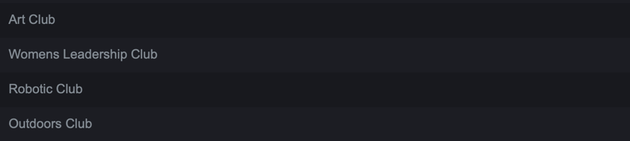

- Retrieve the advisor supervising the highest number of clubs

SELECT CONCAT(A.AFirstName, ' ', A.ALastName) AS AdvisorName, COUNT(S.CID) AS TotalClubsSupervised
FROM Advisor A, Supervises S
where A.AID = S.AID
GROUP BY A.AID
HAVING COUNT(S.CID) = (
SELECT MAX(ClubCount) AS MaxClubCounts
FROM (
SELECT COUNT(CID) AS ClubCount
FROM Supervises
GROUP BY AID
) AS ClubCounts
);
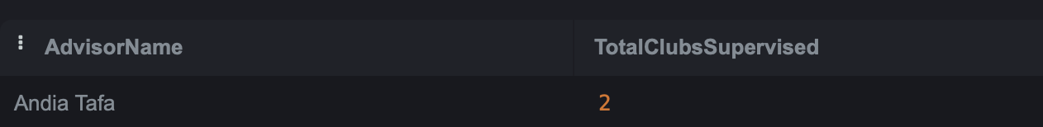
- FRONT END

